Name _________________________________________________________ Date ____________________________
Perimeter and Area of Polygons using the Distance Formula
Use the distance formula: to calculate the perimeter of each polygon. Leave answers in exact form. Show your work on a separate sheet of paper.
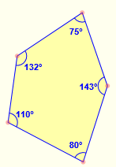
Types of Polygons: Convex vs. Concave
A convex polygon is defined as a polygon with all its interior angles less than 180°. This means that all the vertices of the polygon will point outwards, away from the interior of the shape. Think of it as a 'bulging' polygon. No line that contains a side of the polygon contains a point in the interior of the polygon.
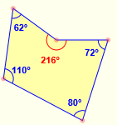
A concave polygon is defined as a polygon with one or more interior angles greater than 180°. It looks sort of like a vertex has been 'pushed in' towards the inside of the polygon. Note that a triangle (3-gon) can never be concave.

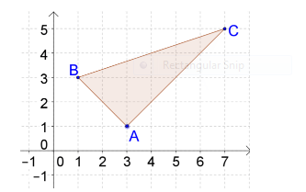
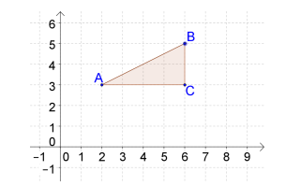
1. 2.

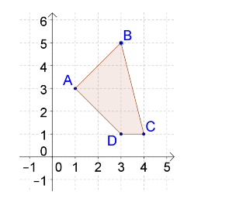
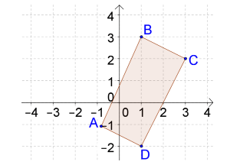
3. 4.

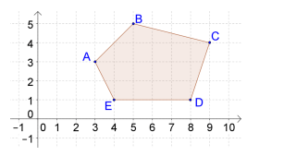
5.

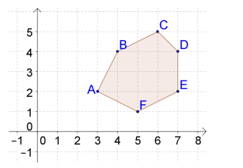
6.

Calculate the area of #1,2,and 3. Can you think of a way to calculate the area of # 4,5, and 6? If so, try it

